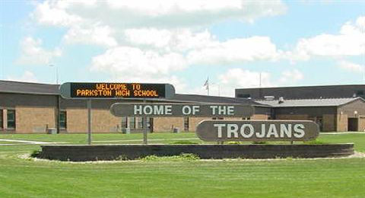 |  | Parkston School District  - Our Home Inc. PRTF  - Issue Date
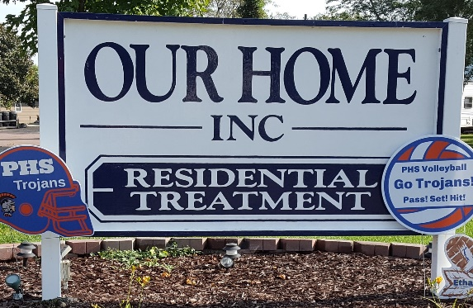

Educational Responsibilities for Students Attending Our Home Inc. PRTF
Your child will be attending school at Our Home Inc. PRTF through the Parkston School District. The responsibilities below will provide more information regarding your child’s educational program.

Parents
-complete necessary paperwork for enrollment
-inform resident district regarding current placement status
-attend parent teacher conferences (in person or by phone)
-attend annual IEP meeting
-contact resident district regarding IEP information and services
-contact Parkston School District teachers of current student progress

Resident District
-forward education records to Parkston School District
-maintain IEP paperwork while student is enrolled with Our Home Inc. PRTF
-pay tuition as applicable

Parkston School District
-communicate with resident district regarding student progress
-communicate with resident district regarding special education services
-assist resident district in maintaining IEP information by providing input for progress, goals and objectives
-maintain report card and other educational records
-notify resident district of applicable tuition rates

Our Home Inc. PRTF
-when allowed, share educational information with Parkston School District teachers
-provide educational support to students through study times in the residential setting

Our Home Inc. PRTF
Jade Hamilton, Program Coordinator
jhamilton@ourhomeinc.org
103 W Maple Street
Parkston SD 57366
Phone (605) 928-7907
FAX (605) 928-7910
http://www.ourhomeinc.org/

Parkston School District 33-3
Eric Norden, High School Principal
Eric.Norden@k12.sd.us
Kay Weber, Special Education Teacher
at Our Home Inc. PRTF
Kay.Weber@k12.sd.us
102 A South Chapman Drive
Parkston SD 57366
Phone (605) 928-3368
FAX: 605) 928-4032
www.parkston.k12.sd.us

